Assembly and
Operation of the


CW Transmitter Module
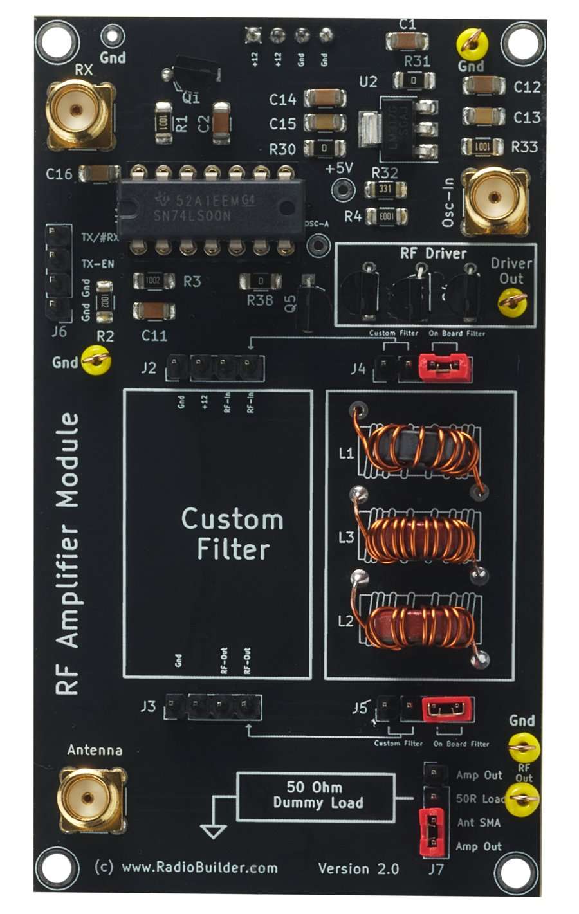
Component of the RadioLab
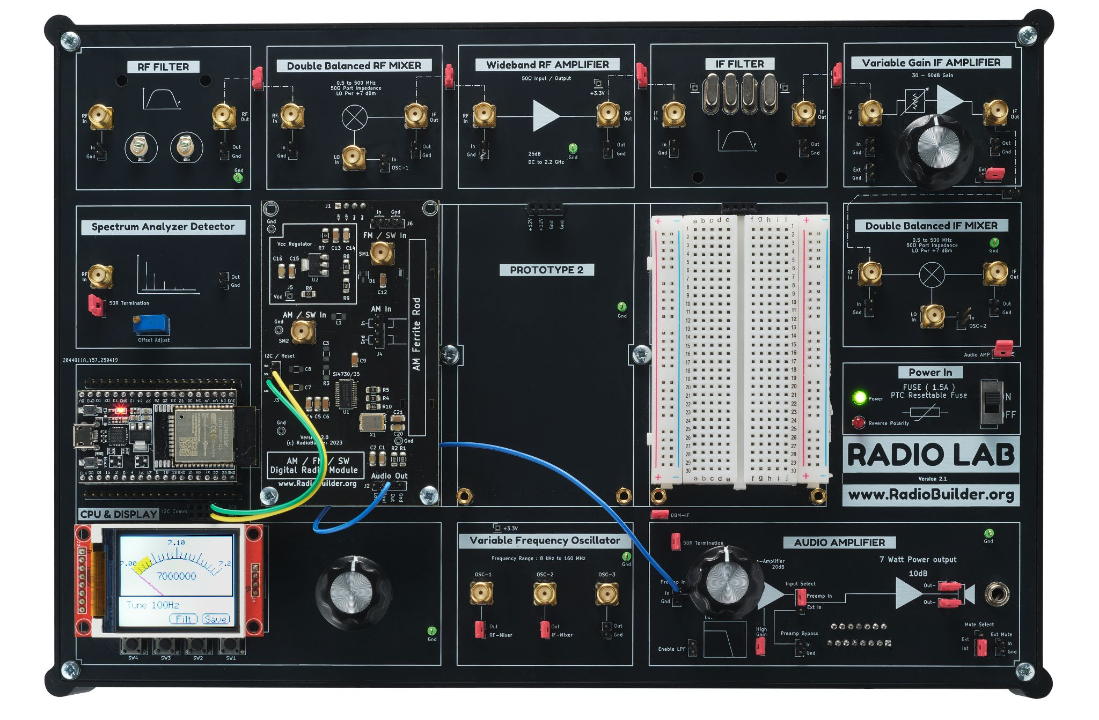

Contents
1.0 CW Transmitter Overview 3
1.1 CW Transmitter Module Specifications 3
2.0 CW Transmitter Theory 4
2.1 Theory of Operation 4
2.2 Connection Diagram 5
2.3 Antenna and Dummy Load 5
2.4 Jumper Configuration 6
2.5 Operation 6
3.0 Schematic Diagram 8
4.0 Circuit Description 9
4.1 Power Supply (U2) 9
4.2 Oscillator Gate (U1) 9
4.3 Soft Keying (Q5) 9
4.4 RF Driver (Q2 – Q4) 9
4.5 40 m Low Pass Filter 9
4.6 T/R Switch (Q1) 10
4.7 50 Ω Dummy Load 10
5.0 Embedded Software 11
6.0 Signal Tracking 12
6.1 DC Test Point Voltages 12
6.2 RF Signal Tracking 12
7.0 Experiments 13
7.1 Measuring Output Power 13
7.2 Harmonics 13
7.3 Key Clicks 13
7.4 Custom Filter for Another Band 13
7.5 Sidetone and Break-in 13
8.0 Assembly 14
8.1 Step 1 - Wind the Filter Inductors 14
8.2 Step 2 - Socket and SN74LS00 15
8.3 Step 3 - Test Points 15
8.4 Step 4 - Jumpers 15
8.5 Step 5 - Complete Assembly 16

1.0 CW Transmitter Overview
Continuous wave (CW) is the simplest form of radio transmission: a carrier switched on and off to send Morse code. It needs only an oscillator, an amplifier and a filter, and a CW signal can be copied at levels where speech is lost in the noise. Many amateurs have made their first contacts with low power CW transmitters.
The RadioLab CW Transmitter Module (marked RF Amplifier Module on the PCB) amplifies the VFO signal to drive an antenna on 40 m. It has a switching RF driver, a low pass filter to remove harmonics, a transmit/receive switch and an on-board 50 Ω dummy load. With the RadioLab receiver modules it forms a complete superheterodyne CW transceiver.

1.1 CW Transmitter Module Specifications
Parameter | Typical Value
Band (on-board filter) | 40 m, 7.000 – 7.200 MHz
Mode | CW
RF driver | 3 × BS170 MOSFET in parallel, switching
Drive input | VFO OSC-3 square wave on Osc-In (SM2)
Output filter | 40 m low pass, 2nd harmonic trap ≈ 14.5 MHz
Keying | Soft keying, 100 µs time constant
T/R switching | BS170 receive switch (Q1), full break-in
Output power | 3-5 Watts
Dummy load | 50 Ω (25 × 50 Ω resistors)
Connectors | RX (SM1), Osc-In (SM2), Antenna (SM3)
Supply | +12 V on J1, +5 V on-board regulator

2.0 CW Transmitter Theory
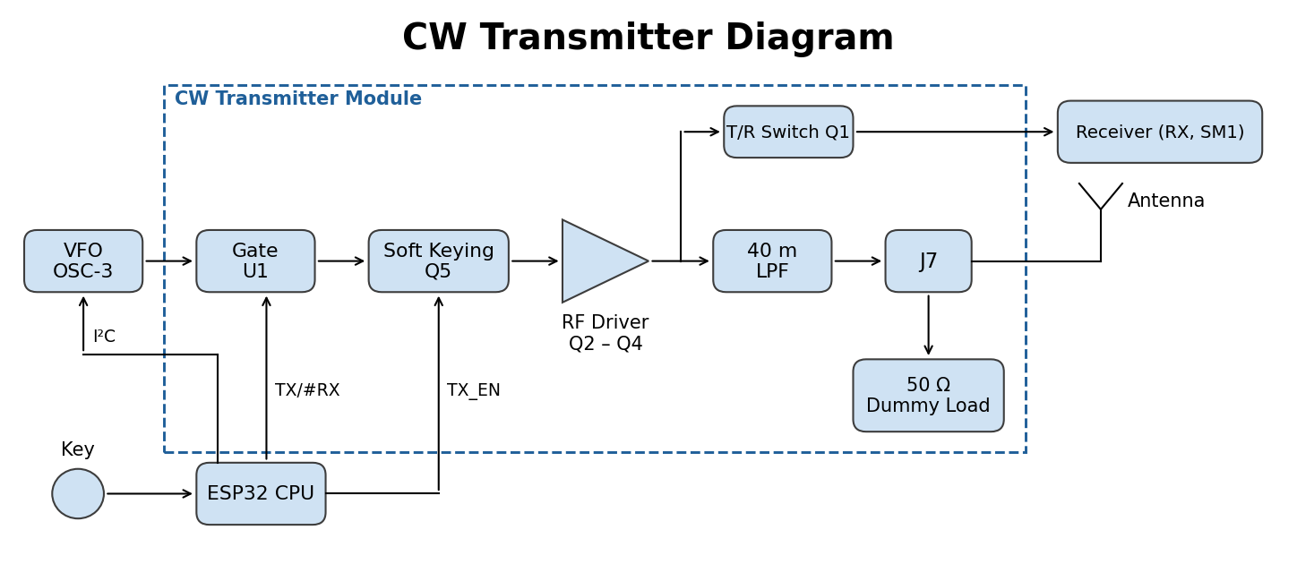
Block Diagram

2.1 Theory of Operation
The VFO module produces a square wave at the transmit frequency on OSC-3. This enters the module at Osc-In and passes through a logic gate (U1) that lets the signal through only when the CPU selects transmit (TX/#RX low).
The gated signal passes through the keying switch Q5, controlled by the TX_EN line. An RC network slows the switch so the carrier rises and falls over about 100 µs instead of switching instantly. Hard on/off keying produces clicks that spread either side of the signal. Shaping the edges keeps the signal narrow.
The keyed square wave drives three BS170 MOSFETs (Q2 – Q4) in parallel. They act as a switch, turning fully on and off at the RF frequency. A switching amplifier is efficient, but its output is rich in harmonics at 2×, 3× and more times the transmit frequency.
The 40 m low pass filter passes 7 MHz and removes the harmonics before the signal reaches the antenna. Jumper J7 sends the output to the antenna (SM3) or to the on-board 50 Ω dummy load for testing.
On receive, the RF driver is off and Q1 connects the antenna, through the low pass filter, to the RX output (SM1) and the receiver modules. On transmit, Q1 turns off to protect the receiver.

2.2 Connection Diagram
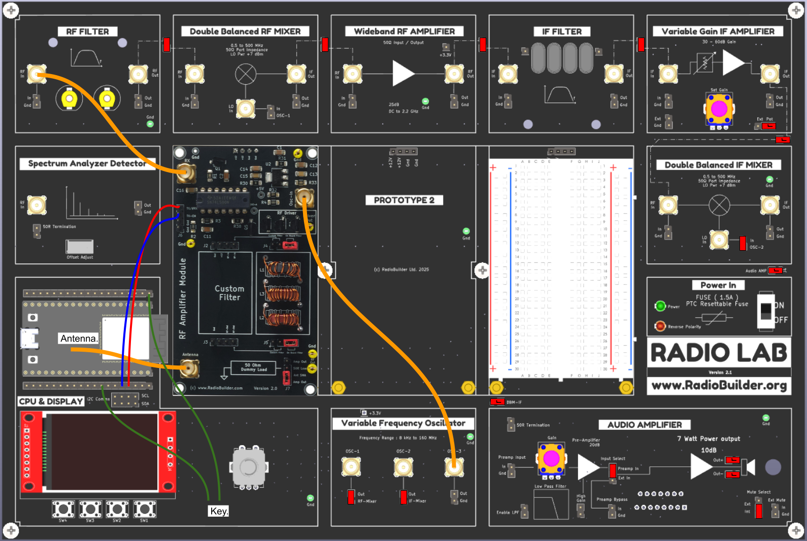
Connection Diagram
- Antenna (SM3) – 40 m antenna.
- RX (SM1) – RF In of the RF Filter (start of the receiver chain).
- Osc-In (SM2) – OSC-3 on the Variable Frequency Oscillator.
- TX/#RX, TX-EN (J6) – ESP32 on the CPU & Display board, see table below.
- Key – Morse key to the CPU & Display board.
The receiver chain is the RadioLab superheterodyne: RF Filter, Double Balanced RF Mixer (OSC-1), Wideband RF Amplifier, IF Filter, Variable Gain IF Amplifier, Double Balanced IF Mixer (OSC-2) and Audio Amplifier.
Control Connections (J6)
J6 Pin | Signal | Connect To | Function
4 | TX/#RX | ESP32 [TBC] | High = receive, low = transmit
3 | TX-EN | ESP32 [TBC] | High = carrier on (key down)

Gnd (J6 pins 1 and 2) is not required. Ground is connected through the supply header J1.

2.3 Antenna and Dummy Load
Always test with the dummy load first. Set J7 to 50R Load, check the output at RF Out, then set J7 to Ant SMA and connect a 40 m antenna to SM3. A resonant dipole or end-fed wire with an SWR below 2:1 is required. Never transmit into an open or badly matched antenna.
A licence is required to transmit. Operate only on frequencies and power levels permitted by your licence.

2.4 Jumper Configuration
Jumper | Setting | Function
J4 | On Board Filter | RF driver to the on-board 40 m filter
J4 | Custom Filter | RF driver to the Custom Filter area (J2)
J5 | On Board Filter | On-board filter output to J7
J5 | Custom Filter | Custom Filter output (J3) to J7
J7 | Ant SMA – Amp Out | Output to the antenna (SM3)
J7 | 50R Load – Amp Out | Output to the 50 Ω dummy load

J4 and J5 must both be set to the same filter.
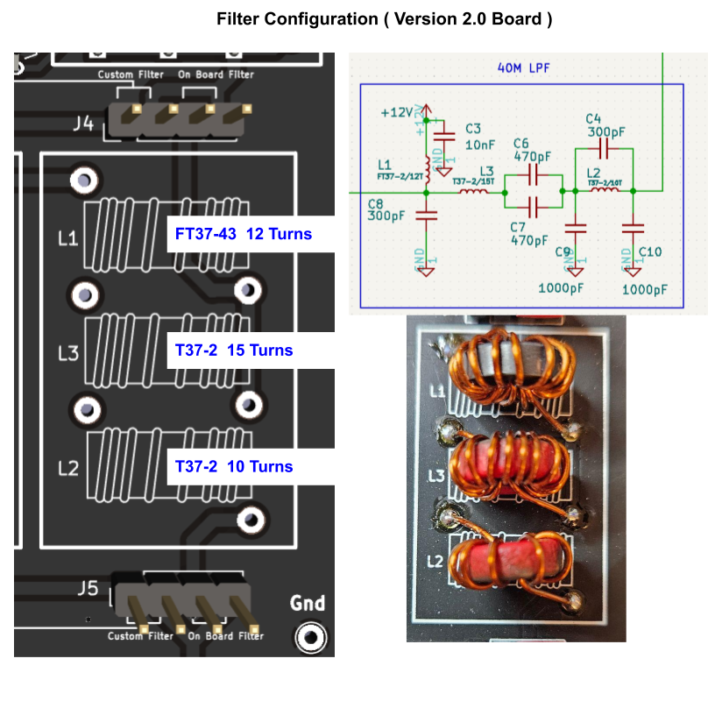
Filter Configuration

2.5 Operation
- Download the SuperheterodyneTranciever sketch to the board.
- Set J4 and J5 to On Board Filter and J7 to 50R Load.
- Connect the modules as shown in the connection diagram.
- Switch on. The display shows OSC-1, OSC-2 and OSC-3. OSC-1 is shown as the dial frequency plus the IF.
- Press the encoder to select a line and turn it to tune. OSC-1 and OSC-2 tune in 100 Hz steps.
- Tune a CW signal so its tone is approx 800 Hz. The transmitter is then on the same frequency.
- Press the key or SW4 to transmit.
- Press SW2 to send "CQ CQ CQ De TEST TEST TEST PSE K" every 5 s. Press SW3 to stop.

3.0 Schematic Diagram
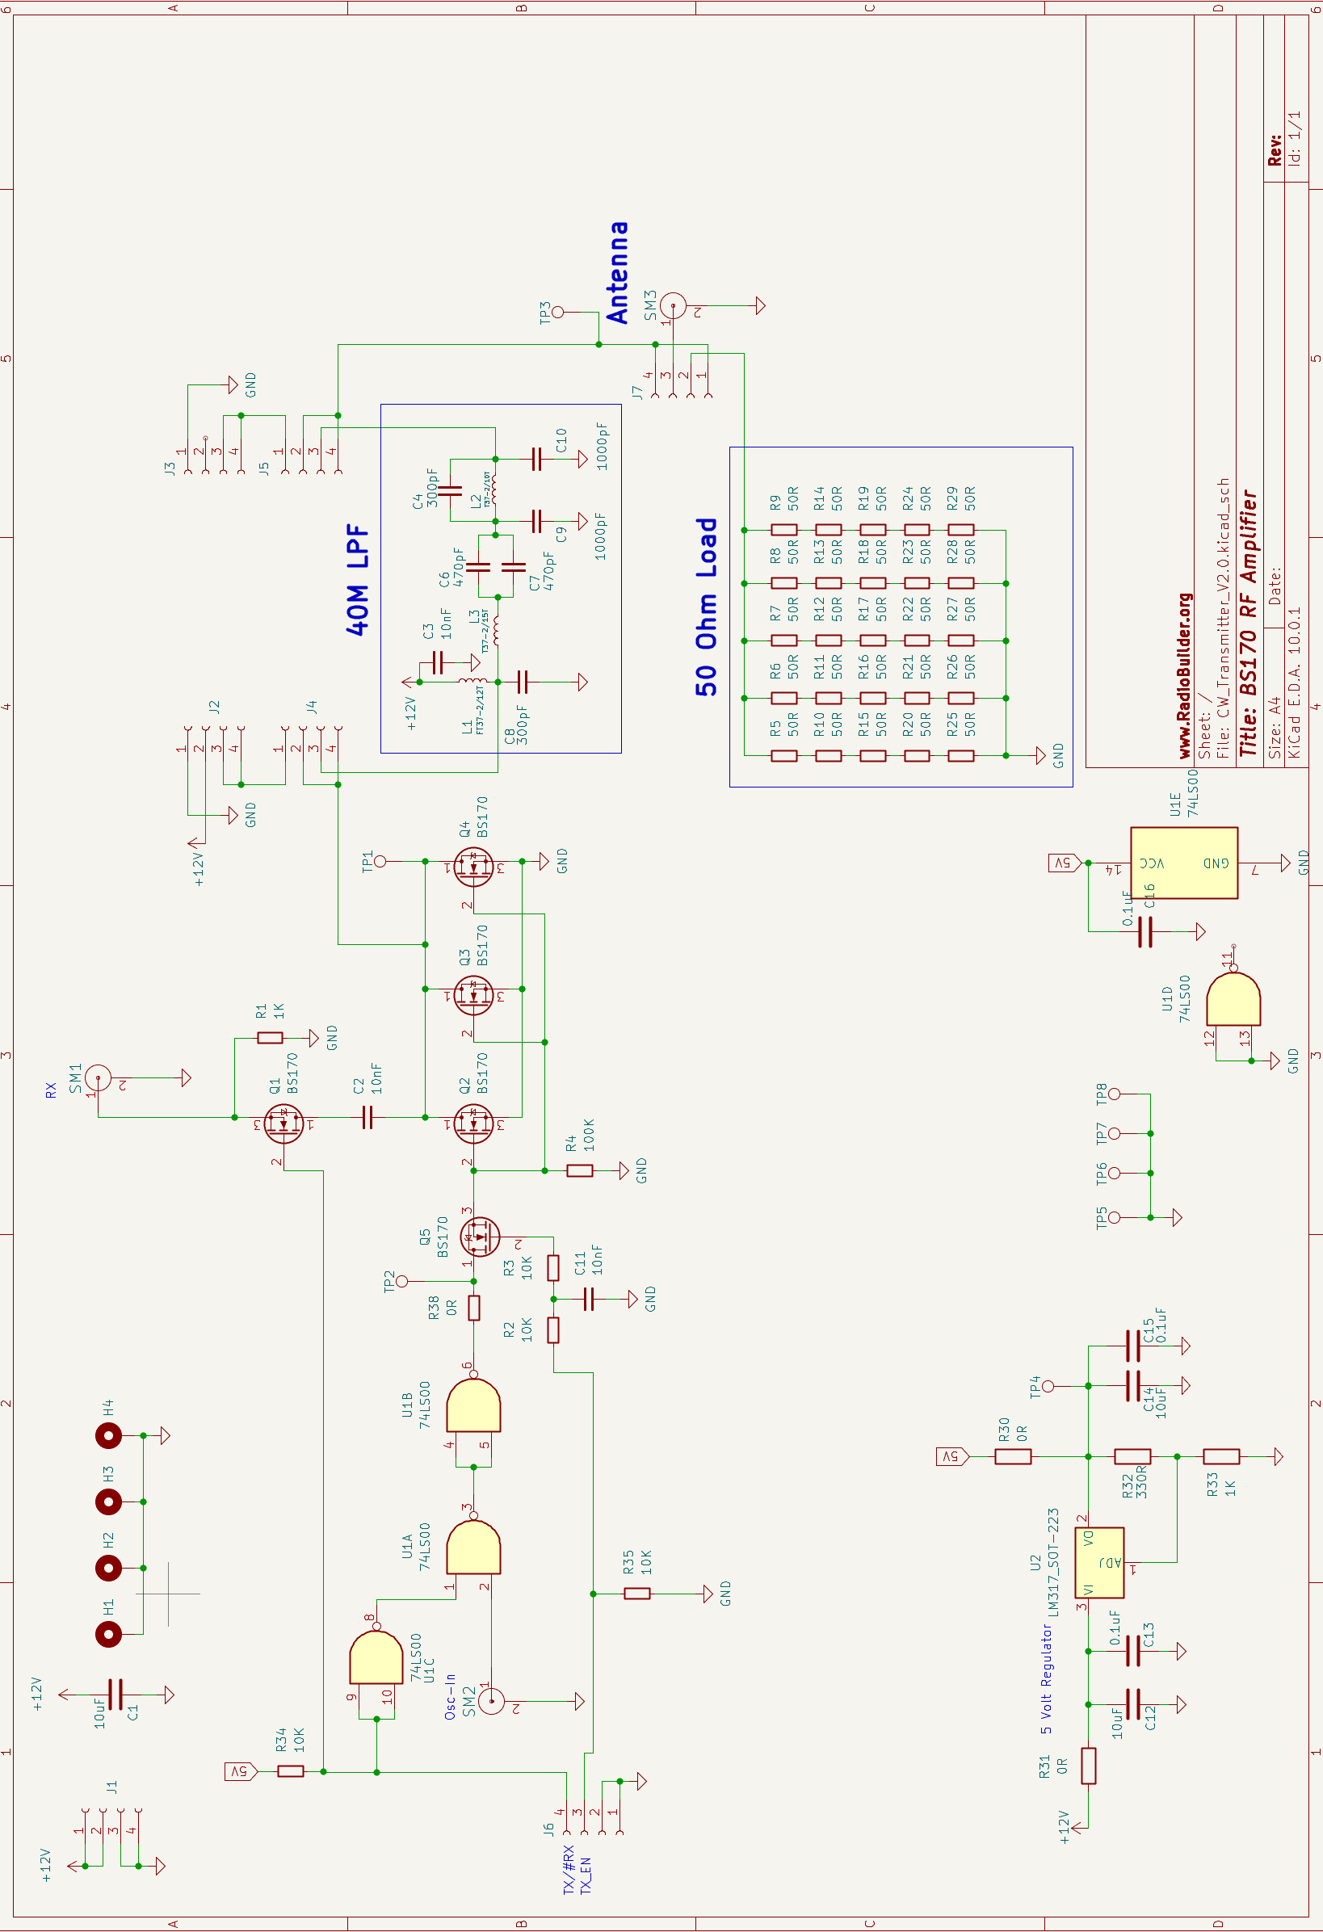
CW Transmitter Module Schematic

4.0 Circuit Description

4.1 Power Supply (U2)
The module takes +12 V from J1. The RF driver runs from +12 V. An LM317 regulator (U2) produces +5 V for the logic and switching circuits. The output voltage is set by R32 and R33:
Vout = 1.25 V × (1 + R33 / R32)
Vout = 1.25 V × (1 + 1000 / 330) = 5.04 V
- C12, C13 (10 µF, 0.1 µF) – input decoupling.
- C14, C15 (10 µF, 0.1 µF) – output decoupling.
- R31 (0 Ω) – input link. R30 (0 Ω) – output link to the +5 V rail.
- TP4 – +5 V test point.
- C1 (10 µF) – +12 V decoupling. C16 (0.1 µF) – U1 decoupling.

4.2 Oscillator Gate (U1)
U1 is a 74LS00 quad NAND gate. U1C inverts the TX/#RX line. U1A passes the oscillator from Osc-In only when U1C output is high, that is when TX/#RX is low (transmit). U1B inverts the signal back to the original phase and drives the keying switch. On receive, the output of U1B is held low and no drive reaches the RF driver.
R34 (10 kΩ) pulls TX/#RX high, so the module defaults to receive if the control line is not connected. U1D is not used and its inputs are tied to ground. TP2 (Osc-A) is the gated drive signal.

4.3 Soft Keying (Q5)
Q5 (BS170) is a series switch between U1B and the gates of the RF driver. TX_EN drives its gate through R3 and R2 (10 kΩ each) with C11 (10 nF). The RC time constant is:
τ = R × C = 10 kΩ × 10 nF = 100 µs
The gate voltage, and so the RF drive, rises and falls over a few time constants when the key is pressed and released. This shapes the CW envelope and reduces key clicks. R35 (10 kΩ) holds TX_EN low when not driven. R4 (100 kΩ) discharges the RF driver gates when Q5 is off.

4.4 RF Driver (Q2 – Q4)
Q2, Q3 and Q4 are BS170 MOSFETs connected in parallel. Their gates are driven by the keyed square wave, their sources are grounded and their drains connect to TP1 (Driver Out). Each MOSFET is fully on or fully off, so little power is lost in the transistors. Three in parallel share the current and the heat.
The drains are fed from +12 V through L1, an RF choke of 12 turns on an FT37-43 ferrite toroid (≈ 50 µH). C3 (10 nF) decouples the +12 V end of L1.

4.5 40 m Low Pass Filter
The filter follows the RF driver and removes harmonics of the transmit frequency:
- C8 (300 pF) – shunt capacitor at the drain.
- L3 (T37-2, 15 turns, ≈ 0.9 µH) with C6 || C7 (2 × 470 pF) – series tuned circuit.
- C9 (1000 pF) – shunt capacitor.
- L2 (T37-2, 10 turns, ≈ 0.4 µH) with C4 (300 pF) – parallel trap.
- C10 (1000 pF) – shunt capacitor at the output.
L2 and C4 resonate at the second harmonic and block it:
f = 1 / (2π × √(L × C)) = 1 / (2π × √(0.4 µH × 300 pF)) ≈ 14.5 MHz
Inductance values are calculated from the core AL values (T37-2: 4.0 nH/turn², FT37-43: 350 nH/turn²).
J4 and J5 select between this filter and a filter built in the Custom Filter area. J2 (Gnd, +12, RF-In, RF-In) and J3 (Gnd, RF-Out, RF-Out) are the custom filter connections. A custom filter allows other bands to be used.

4.6 T/R Switch (Q1)
Q1 (BS170) connects the antenna path to the RX output (SM1) through C2 (10 nF). Its gate is driven by TX/#RX: high on receive (Q1 on), low on transmit (Q1 off). R1 (1 kΩ) terminates the RX output. On receive, the antenna signal passes through the low pass filter to Q1, so the filter also protects the receiver from strong signals above 40 m.

4.7 50 Ω Dummy Load
Twenty-five 50 Ω resistors (R5 – R29) form the dummy load: five strings of five resistors in series (250 Ω each), with the five strings in parallel.
R = 5 × 50 Ω / 5 = 50 Ω
Spreading the power over 25 resistors lets the load absorb more power than a single resistor. J7 connects the amplifier output (Amp Out) to the dummy load (50R Load) or the antenna connector (Ant SMA). TP3 (RF Out) is the output test point.

5.0 Embedded Software
The SuperheterodyneTranciever sketch runs on the ESP32 on the CPU & Display board. It controls the Si5351 on the VFO module and the TX/#RX and TX_EN lines of this module.
Required libraries
- Etherkit Si5351 – VFO.
- TFT_eSPI (Bodmer) – display.
- AiEsp32RotaryEncoder – tuning encoder.

VFO Output | Receive | Transmit
OSC-1 (CLK0) | Dial + IF (RF mixer LO) | Dial + IF
OSC-2 (CLK1) | IF (BFO, 9.216283 MHz) | Dial − 200 Hz
OSC-3 (CLK2) | Off | Dial − 800 Hz (transmit frequency)

Transmit frequency – The transmitter is 800 Hz below the dial frequency. A station received with an 800 Hz tone is on the same frequency as the transmitter.
Sidetone – On transmit, OSC-2 moves to the dial frequency − 200 Hz, 600 Hz above the transmit frequency, to produce the sidetone.
Break-in – When the key is released, TX_EN goes low and TX/#RX goes high at once. The oscillators return to receive after 500 ms without keying.
Morse sender – SW2 sends a CW message from the sketch. The dot length is 100 ms, which is 12 words per minute. Change DOT_TIME in cw.h to change the speed and edit the text in SendSequence() to change the message.
Control | Function
Encoder turn | Tune the selected oscillator
Encoder press | Select OSC-1, OSC-2 or OSC-3
SW4 / Key | Transmit (key down)
SW2 | Start the CQ message
SW3 | Stop the CQ message

6.0 Signal Tracking
Set J7 to 50R Load for all transmit measurements.

6.1 DC Test Point Voltages
Test Point | Receive | Transmit (key down)
J1 pin 1 | +12 V | +12 V
TP4 (+5 V) | 5.04 V (4.85 – 5.20 V) | 5.04 V
J6 TX/#RX | 3.3 V | 0 V
J6 TX-EN | 0 V | 3.3 V
TP1 (Driver Out) | +12 V | RF, see below

6.2 RF Signal Tracking
- SM2 (Osc-In) – square wave at the transmit frequency when transmitting.
- TP2 (Osc-A) – gated square wave, present only on transmit.
- TP1 (Driver Out) – switching waveform at the drains of Q2 – Q4.
- TP3 (RF Out) – filtered sine wave into the dummy load.
Output power into the dummy load is calculated from the RMS voltage at TP3:
P = V² / R = V² / 50 Ω
Example: 7.07 V RMS (20 V peak-to-peak) at TP3 is 7.07² / 50 = 1.0 W.

7.0 Experiments

7.1 Measuring Output Power
With J7 on 50R Load, key the transmitter and measure TP3 with a scope. Calculate the output power with P = V² / 50. Repeat with one, two and three BS170s fitted (Q2 – Q4) to see how the parallel devices share the load.

7.2 Harmonics
Connect TP1 and then TP3 to the Spectrum Analyzer Detector through a suitable attenuator. Compare the harmonics at 14 MHz and 21 MHz before and after the low pass filter.

7.3 Key Clicks
Send a string of dots and watch the RF envelope at TP3 on a scope. Change C11 to 1 nF and to 100 nF and note the rise and fall of the envelope. Listen on a second receiver for clicks either side of the signal.

7.4 Custom Filter for Another Band
Build a low pass filter for another band in the Custom Filter area, set J4 and J5 to Custom Filter, and tune the VFO to the new band. Check the harmonics before connecting an antenna.

7.5 Sidetone and Break-in
Change QSK_TIME in the sketch and note how long the receiver takes to recover after the key is released. Change the 200 Hz offset on OSC-2 to change the sidetone pitch.

8.0 Assembly
The surface mount parts and connectors are fitted. To complete the module, wind and fit the three filter inductors, fit the socket and SN74LS00, fit the test points and set the jumpers.
Part | Qty
CW PCB | 1
Enamelled Wire (700 mm length) | 1
FT37-43 Toroid | 1
T37-2 Toroid | 2
Test Points | 2
14 Pin Socket | 1
SN74LS00N | 1
Jumper | 3

8.1 Step 1 - Wind the Filter Inductors
Inductor | Core | Turns | Wire Length (approx)
L1 | FT37-43 (black) | 12 | 210 mm
L3 | T37-2 (red) | 15 | 250 mm
L2 | T37-2 (red) | 10 | 190 mm

- Cut the wire for each inductor from the 700 mm length. Wind L3 first, as it needs the most wire.
- Pass the wire through the centre of the toroid. Each pass through the centre is one turn.
- Wind the turns in the same direction, with even tension, spread evenly around the core.
- Scrape or burn the enamel off the ends and tin them.
- Solder each inductor into its position (L1, L3, L2) as shown below. Do not mix up L3 and L2.
Filter Inductors

8.2 Step 2 - Socket and SN74LS00
Insert and solder the 14 pin socket in U1 with the notch matching the PCB outline. Insert the SN74LS00N into the socket with pin 1 at the notch.

8.3 Step 3 - Test Points
Insert and solder the two test points in GND positions.

8.4 Step 4 - Jumpers
Fit the three jumpers: J4 and J5 to On Board Filter, J7 to 50R Load.

8.5 Step 5 - Complete Assembly
Completed CW Transmitter Module

